Let's change the name to **HCCS MRITA (Monitoring & Retrieval of IT Assets)** to make it more appropriate. Skunkworks is just a placeholder name since we have not yet thought of a proper name yet.

I also have some concerns regarding the viewer.

(Please refer on the encircled numbers in the screen shot)

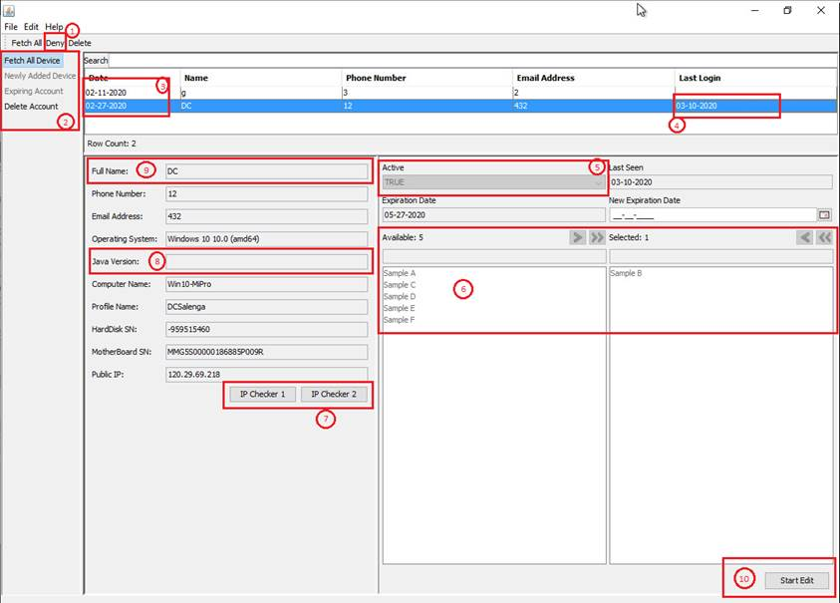

1. What is your plan with the 'Deny' menu.
2. Sub Menu on the left panel.
   * I think 'Newly Added Device' is not that important to monitor, so it does not need to have it's own filter.
   * Use 'Fetch All Devices' instead.
   * 'Terminated Devices' instead of 'Expiring Accounts'. This filter are for the devices that are used by terminated employees that needs retrieval.
   * Let’s add a filter for 'Retrieved Devices'. This filter are for devices that are retrieved from terminated employees.
   * Does these menus filter the display table, or is it another form?
   * Delete Account should be a toolbar button. And let's change it to 'Retrieve Device'. Let's also add a toolbar button for 'Terminate Device'.
   * We should have 3 statuses for devices. 'Active', 'Terminated' and 'Retrieved'.
   * 'Terminate Device' button sets the status of the device to 'Terminated', records the 'Termination Date', and sets the bug status to 'Triggered'.
   * 'Retrieve Device' button sets the status of the device to 'Retrieved', records the 'Retrieval Date', and sets the bug status to 'Dormant'.
   * When creating a device for monitoring, record the ‘Acquisition Date'.
   * Maybe we can remove this here, and make it a filter above the table? that way, we can save space.

1. What is this date for? I guess it's for your Expiration date.

* I suggest to add the 3 dates mentioned above to the table.

1. Please include the time (with TZ) in this column, and change it to Date Last Used

* I would suggest to set the display table design to be:

                                                | Employee | Device Type | Status | Phone # | Email Address | PC Bug Status | Days Not Surrendered | Date Last Used | IP |

* Let's include device type in the properties of the record. 'Desktop' and 'Laptop' would suffice. Please put these in the database so we can add new device types in the future.
* 'Bug Status' displays the status of the bug in the borrowed device. 'Dormant' when the bug is not yet installed in the device. 'Live' if it has made contact. 'Triggered' when the bug is active.
* 'Days Not Surrendered' are the number of days from Termination Date up to now.
* 'IP' displays the 'IP' of the device when it is last used.
* Also let's make the table longer, so we can see more devices. If we can add pagination for this, that would be great.

1. Let's change this to 'Device Status', and drop down for the 3 device statuses above.
   * Last Seen field, is this the same with the last login column? If it is, no need to add this to the editor.
   * Employee Device Allocations do not have Expiration dates, let’s remove it. instead lets have an editor for the 3 dates above. Only Acquisition Date is required and has a default value of 'Now'.
   * Let's add a UUID field for Bug Id. This is the link between the device's record and the installed bug in the borrowed PC. (I will let you handle how this functions).
   * Let's Add a drop down field for 'Bug Status', this overrides the activation of the bug in the borrowed device. values are 'Dormant', 'Live' and 'Triggered'

1. What is the function of this control for? If this is for peripheral devices included borrowed device, let's change it to a more robust way to list down.

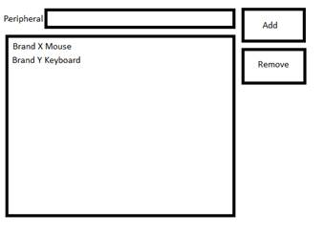

1. What are these IP Checkers for? I clicked them and it just transferred me to a site that displays my public IP. I think we don't need this field since we do not know what is the IP the employee will use for this device. We can determine this in the 'IP' when the device is last used (Item #4).
2. We do not need to know this. Let's remove this from the editor.
3. Let's Change it to 'Employee Name'.
   * Let's Add the device type to this editor, A drop down field with the types from the database.
   * The other data for OS and Serial Numbers, can be nullable, and can they be set when the PC bug goes live?
4. 'Start Edit', can we move this to the toolbar?       Also let's have the CRUD buttons for this editor.

I have further questions regarding the project as a whole. Since you're using Java, will all the windows versions and architectures be handled? I noticed that the viewer only works for Java 64bit, this is fine since Lou and company probably has 64bit systems. The bugs on the other hand will be deployed in different versions and architecture, this posed as a problem with ChartStream, I am just wondering how you will handle it? Also what happens if the User uninstalled their java? I think this will be a big problem for the bug.

------------------------------------------------------------------------------------------------------------------------------------------------------------------------------------------------------------------

I am lazy to remove the reviews I’ve done above and re write it to suit my next pitch, so I will just leave them there.

The requests above are applicable to the ones below. If you have questions for the items below, please refer to the list above.

Based on the Viewer you’ve given us, we have ideas and requests we want to pitch with you.

**Monitoring Module**

This will be the same as your viewer, only with more concise data presented. Re design as you see fit, this is just a suggestion.

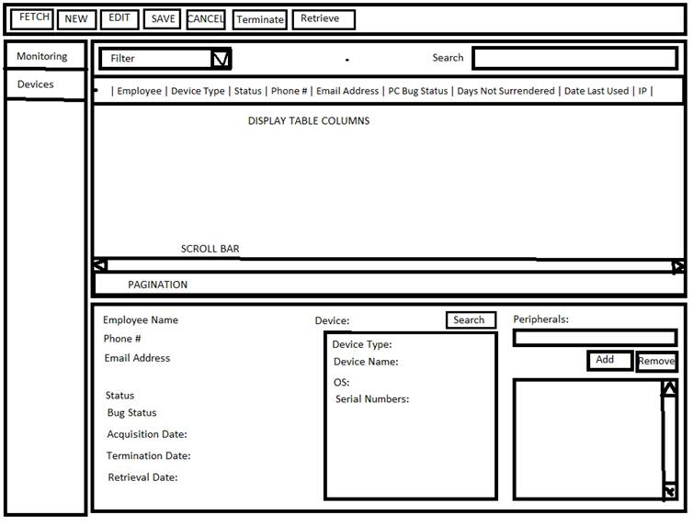

                Default sorting is by status (1) Terminated  (2) Active (3) Retrieve,

                                Terminated sorting are by Days Not Surrendered descending, then Employee Name.

                                Active sorting are by Employee Name.

                                Retrieve sorting are by Emplyee Name.

                PC Bug Status with value of ‘Triggered’ should have red font color.

                Filter can have the values ‘All’, ‘Active’, ‘Terminated’, ‘Retrieved’

                                ‘All’ – all allocations

                                ‘Active’ – all allocated devices with the status of Active.

                                ‘Terminated’ – all allocated devices that are terminated.

                                ‘Retrieved; - all allocated devices that are retrieved.

                You can add more filters if you want.

                Search bar should be applicable to all values in table.

                Device ‘Search’ Button shows a list dialog where I can select devices.

                                Validation: Devices can only be set if they are not yet allocated or previous allocations have retrieved status.

                                Only active devices can be seen here.

                Details under Device section are un editable.

**Devices Module**

                This module will save records for individual devices, this allows us to re allocate devices when they are retrieved. This is just SCRUD for the devices.

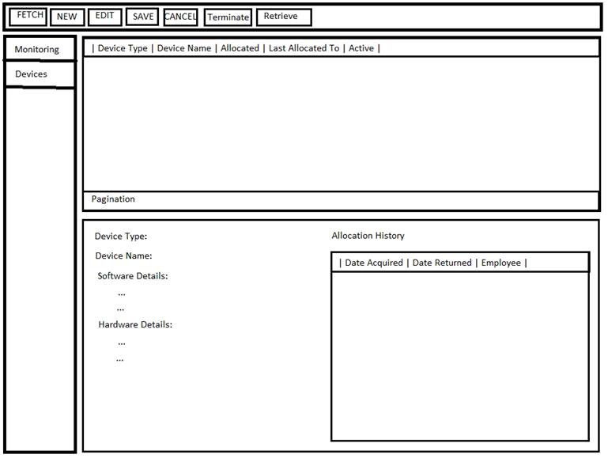

                Allocated field in table is ‘Yes’ when there is an allocation for the device that are still ‘Active’ or ‘Terminated’, otherwise it’s ‘No’.

                Last Allocated To field is to for the last Employee where a device is allocated to.

                Allocated History is a table for showing all allocations made with this device. Sorted by AcquisitionDate descending.